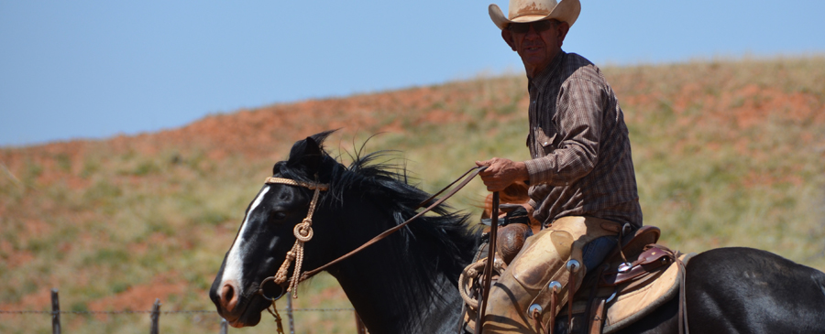
Texoma Cowboy
Church
Cowboying for
jesus

August 2016 Issue # 2

Hobbled by Pastor John

For the Past few weeks I have been preaching about being hobbled. There are many things in life that can hobble us, making us feel stuck and unable to move in life. Cowboys use hobbles on their horses for containment and restraint, allowing their horses to gaze yet keep them in close proximity while the cowboy tends to his work or grabs a quick bite to eat. Some horses actually become quite good at getting around while hobbled. That’s also true for us. We learn how to maneuver through our days hobbled by things of our past, failures, regrets, sin, fear, depression, and the list goes on and on. In the movie Lonesome Dove, Woodrow, Gus, and the rest of the gang leave Lonesome Dove Texas and ride into Mexico at night to steal horses from the famous Mexican Bandit, Pedro Flores. When they find the horses, they also come upon two Irish brothers. When Woodrow and the boys confront the two brothers they jump on their mule for a quick getaway kicking and whipping that mule. Woodrow told them that if they were planning on going anywhere they would first need to unhobble their mule. They were making plenty of noise and doing a lot of kicking but that mule hadn’t made a track. Galatians 5:1 It is for freedom that Christ has set us free. Stand firm, then, and do not let yourselves be burdened again by a yoke of slavery.

News from the Ranch

I don’t know what has you hobbled, but through Christ you can be free indeed. Spend some time with Jesus, and throw off everything that hinders and the sin that so easily entangles, and run with perseverance the race set before you, keeping your eyes on Jesus the author and finisher of your faith.

The 100 plus degree days are here and I’m already looking forward to fall and cooler weather. I hope you and your families have been having some great family time together this summer. I am so thankful for what God is doing through the ministry and family here at TCC. July 24th was our first annual Lake Baptism. Many of us gathered at Lake Arrowhead for fellowship, food (tons of food), fun and praise to God as we Baptized 26!!!!! We saw 31 baptisms the week of July 24 alone. God is on the Move!!!!
Our Ministry teams are gearing up for a great fall. I want to encourage you to get plugged into a ministry team. Our Kids have been to two camps this summer and VBS “Whirl Wind Ranch” August 13th. We are excited to have Patsy Mayo as our new Women’s Ministry team leader. Ladies our church will be hosting “Living Proof” simulcast with Beth Moore in September. Sick “pen”

ministry team will be joining other ministries in Wichita Falls for a “Back to School Bash” on August 13th.
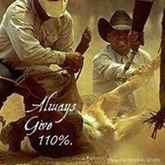

We have also added another small group bible study on Thursday evenings on “Experiencing God”. We have several small groups for you to get plugged into as well. Please begin to pray for the upcoming G12 Cowpuncher Ride.
I want to thank everyone for all the hard work, commitment, and dedication to our Lord and His church. God is on the move!!!
Cowboying For Jesus
Pastor John Riggs

